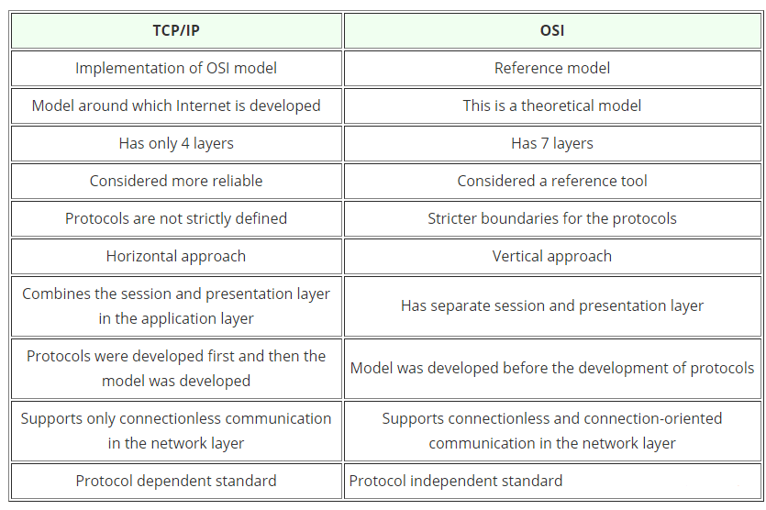

|  |  |
| --- | --- |
| [Layer 7: Application layer network protocols](https://www.manageengine.com/network-monitoring/network-protocols.html#application) | * Provides standard services such as virtual terminal, file, and job transfer and operations. |
| [Layer 6: Presentation layer network protocols](https://www.manageengine.com/network-monitoring/network-protocols.html#presentation) | * Masks the differences in data formats between dissimilar systems. * Encodes and decodes data, encrypts and decrypts data, and compresses and decompresses data. |
| [Layer 5: Session layer network protocols](https://www.manageengine.com/network-monitoring/network-protocols.html#session) | * Manages user sessions and dialogues. * Establishes and terminates sessions between users. |
| [Layer 4: Transport layer network protocols](https://www.manageengine.com/network-monitoring/network-protocols.html#transport) | * Manages end-to-end message delivery in networks. * Renders reliable and sequential packet delivery through error recovery and flow control mechanisms. |
| [Layer 3: Network layer protocols](https://www.manageengine.com/network-monitoring/network-protocols.html#network) | * Routes packets according to unique network device addresses. * Renders flow and congestion control to prevent network resource depletion. |
| [Layer 2: Data link layer network protocols](https://www.manageengine.com/network-monitoring/network-protocols.html#data) | * Frames packets. * Detects and corrects packet transmit errors. |
| [Layer 1: Physical layer network protocols](https://www.manageengine.com/network-monitoring/network-protocols.html#physical) | * Interfaces between network medium and devices. * Defines optical, electrical, and mechanical characteristics. |